MGMS – Account head wise allocation

Detailed Design Document

Ver. 1.4

Version History
Date | Description
22-Nov-2010 | First draft

Table of Contents

Version History 2
1 Introduction 4
2 Head wise allocation 4
3 Associated Tables 8
4 Data Dictionary 8

Introduction

This document provides the detailed design specifications for the Multisite Grant Management System project.

This is not a project plan nor does it detail the source code. It is a guide for system architecture and development, not for phasing, timelines or deliverables.

Finally, this is a ‘living document’ and the specification will change, continuously, as the project proceeds. More details will be added and the existing information edited as the requirements, architecture and design evolve in the course of the project.

Head wise allocation

This deals with allotting portions of the project’s grant allocation to various account heads associated with the project. Currently allotment may be done to sub –account head level also.
So validation required:
- sum of all sub account head allocations should not be more than the allocation for the particular account head
- sum of all account head allocations should not be more than the grant allocations for the project.

Screen & Control Description

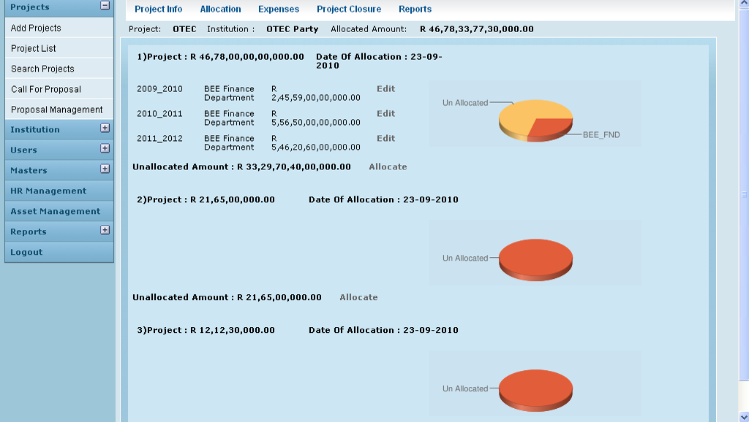

Field /Label | Input-Control | Data Type | Remarks
Project: | Auto populated | varchar(255) | projects>code
Institution: | Auto populated | varchar(255) | party>code
Allocated Amount: | Auto populated | double | grant_allocation>amount_allocated
<Sl No> | Auto increment - populated
Project: |  | varchar(255) | projects>code
<allocated amount> | Auto populated | double | grant_allocation>amount_allocated
Date of Allocation: | Auto populated | datetime | grant_allocation>date_of_allocation
<grant_period> | Auto populated |  | grant_period>name
<sub account head name> | Auto populated | varchar(255) | account_heads>name
<amount_allocated to subaccount head> | Auto populated | double | grant_allocation_split>amount
Edit | Button
Unallocated Amount: | Auto populated | Calculated | allocated amount – amount allocated to sub account heads associated with the project. (2 fields above)
Allocate | Button

Graphical Representation

For each grant allocation to the project, a pie chart displays the account head allocations and the remaining unallocated amount.

Google chart tool is being used here.

Chart Component | Value/Requirement | Remarks/db table>field
Chart type | 3D pie chart
Chart size (width x height) | 300 x 95 pixels
Chart color (slices) | e25d3a,fb363
Chart background fill solid color | cbe2f 0
Chart area gradient fill at angle 45’ color | cbe2f 0  color centre point is 0  cbe2f 0  color centre point is 1
Chart Title | Fund Allocation
Chart title color, font size | 0000ff,1
Chart data | amounts allocated to different account heads | grant_allocation_split>amount;  (grant_allocation>amount_allocated)-(sum of all grant_allocation_split>amount) should be a data and labeled as “unallocated” amount
Slice Labels | account head names | account_heads>name
Legend position | Legend to the right of the chart, legend entries in a vertical column.

Edit

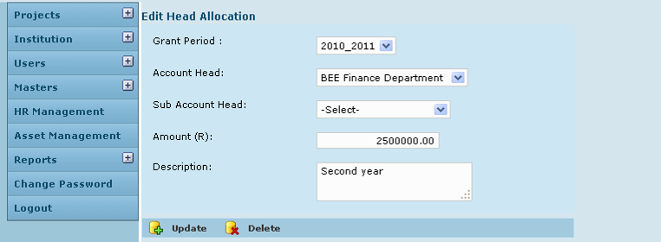

Field /Label | Input-Control | Data Type | Remarks
Edit Head Allocation
Grant Period: | Listbox | varchar(255) | grant_period>name
Account Head: | Listbox | varchar(255) | account_heads>name
Sub account head: | Listbox | varchar(255) | account_heads>name
Amount: | Textbox | double | grant_allocation_split>amount
Description: | Textarea | varchar(255) | grant_allocation_split>description
Update | Button |  | On clicking, same screen refreshes with message – Head allocation updated successfully
Delete | Button |  | The entry deleted

Allocate

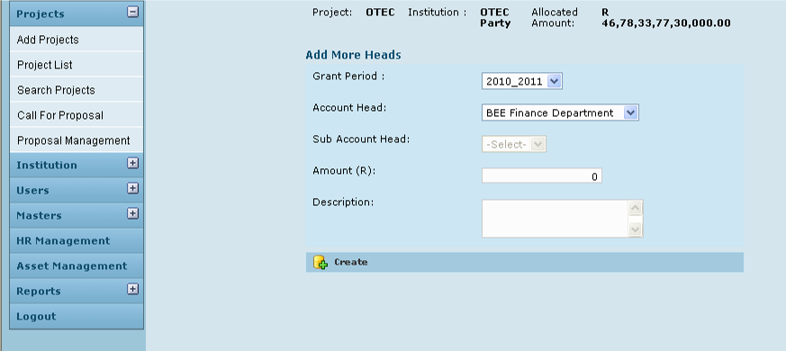

Field /Label | Input-Control | Data Type | Remarks
Project: | Auto populated | varchar(255) | projects>code
Institution: | Auto populated | varchar(255) | party>code
Allocated Amount: | Auto populated | double | grant_allocation>amount_allocated
Add more heads
Grant Period: | Listbox | varchar(255) | grant_period>name
Account Head: | Listbox | varchar(255) | account_heads>name
Sub Account Head | Disabled listbox | varchar(255) | account_heads>name
Amount (R) | Textbox | double | grant_allocation_split>amount
Description | Textarea | varchar(255) | grant_allocation_split>description
Create | Button |  | The record is saved

Associated Tables

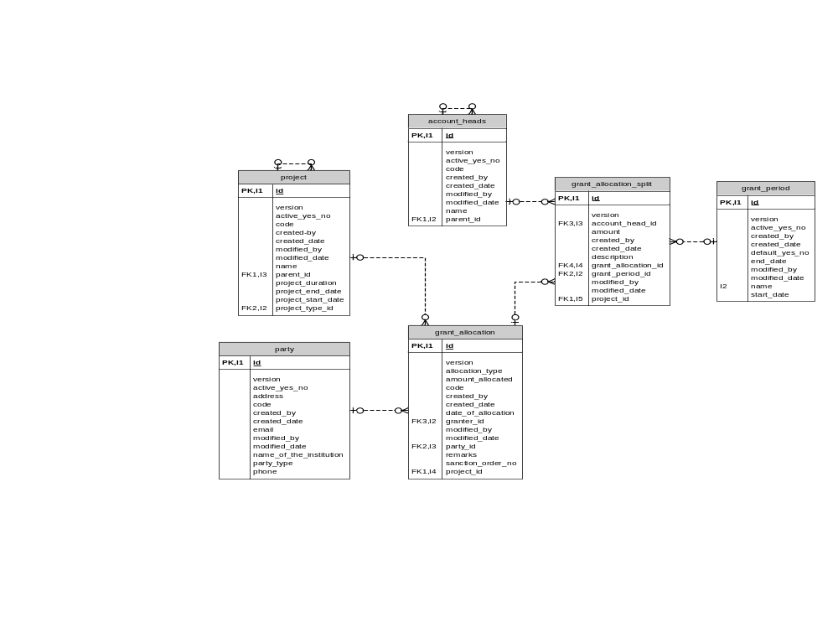

Data Dictionary

